Observation and Inference: Keys to the Past (Grades 9-12)

Tennessee State Standards Covered
CLE 3210. Inq. 1 Interpretation and observation redefine science
CLE 3210. Inq. 6 Reasoning behind interpretations defines science
CLE 3204.4.6 Fossils provide evidence of past life
CLE 3255. Inq. 1 Interpretation and observation redefine science
CLE 3255. Inq. 6 Reasoning behind interpretations defines science
CLE 3255. Inq. 7 Interpretation of data develops scientific theory
CLE 3255. Inq. 10 Alternate explanations of data provides scientific insight
CLE 3295.2.3 Recognize the limitations of scientific observation

Objectives
Students will learn what an inference is and differentiate between inference and observation. They will examine a scene and a series of statements about the scene and then determine which statements are observations and which are inferences.

Background
Modern science is based on observation and inference. Observation is seeing and noting facts. Inference is a proposed reason or assumption based on observation. Paleontologists use these two principles to form theories, or put together a picture of what the past was like. By making observations of fossils they can make inferences about the animals or plants they represent. Also, by making observations of modern day plants and animals that are similar to the fossils, they can make inferences about the past.

Materials
- Handouts (3) for each student or team
  - Dinosaur scene
  - List of statements
  - Petrified Bones and Tracks page

Procedure
Discuss the difference between observation and inference then pass out the handouts. Have the students work individually or in teams. They will determine whether each statement is an observation or an inference. Later, go over their answers as a group, discussing the logic used in making their choices.

Dinosaur Scene:
A time machine has been invented that travels into the past and takes pictures, sending them to the present. You are asked to look at one of the pictures and interpret what you see. Put an “O” before the statements that are observations and an “I” before the statements that are inferences.

1. The volcano is erupting.

2. The Camptosaurus is going to eat the stegosaurus.

3. The Stegosaurus will run into the water to escape.

4. The Camptosaurus is leaving tracks in the ground.

5. The ground where the Camptosaurus is walking is wet.

6. There are plants growing in the water.

7. The Camptosaurus is going into the water to eat the plants.

8. There is a tree growing next to the river.

9. The tree looks like a palm tree.

10. The climate is warm.

11. The Stegosaurus is eating the plant.

12. The Stegosaurus is an herbivore.

13. There are bones from a dead animal by the shore.

14. The Camptosaurus killed the animal.

15. Some more bones are in the water.

16. The Camptosaurus can’t swim and will drown.

17. Lava is corning down the sides of the volcano.

18. The Camptosaurus has sharp teeth for eating meat.

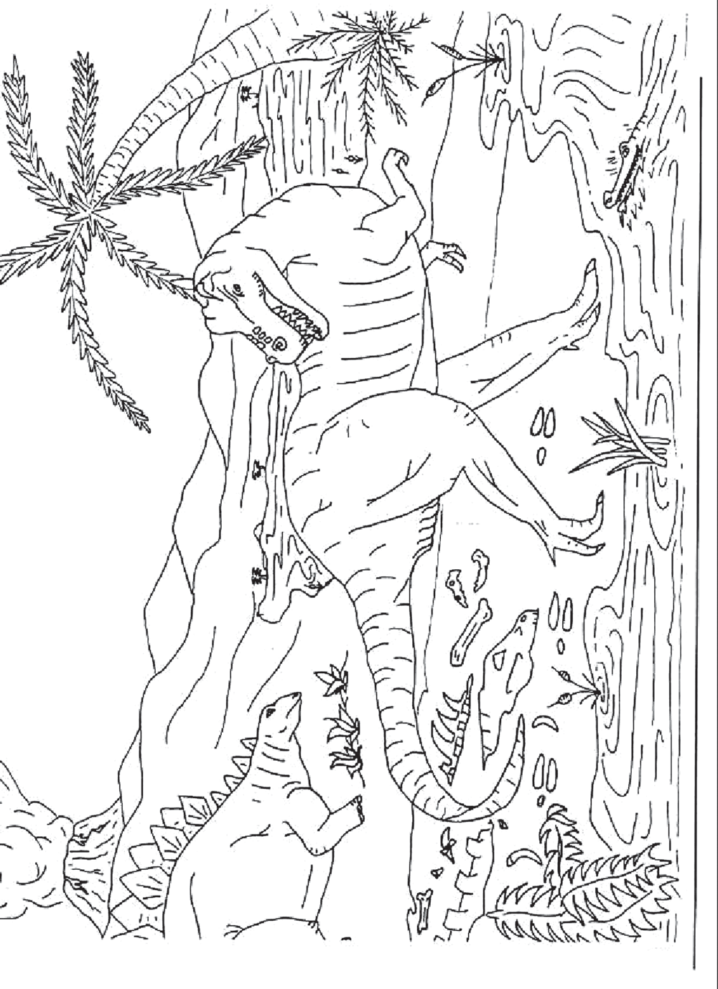

Suppose you are a paleontologist and you have just discovered a layer of rock with many fossils in it, both petrified bones and tracks. Decide whether the following statements are observations or inferences.

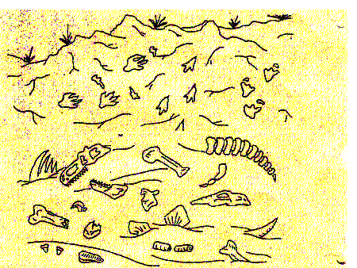

There are tracks from three different animals in the rock.

One animal was chasing another animal.

Two different animals died in this spot.

When the animals walked here the ground was wet.

One of the animals that died here had bony plates.

One of the animals that died here had sharp teeth.

The animal that had sharp teeth ate meat.

KEY FOR TEACHERS

Dinosaur Scene:
A time machine has been invented that travels into the past and takes pictures, sending them to the present. You are asked to look at one of the pictures and interpret what you see. Put an “O” before the statements that are observations and an “I” before the statements that are inferences.

O 1. The volcano is erupting.

I_ 2. The Camptosaurus is going to eat the stegosaurus.

I_ 3. The Stegosaurus will run into the water to escape.

O_ 4. The Camptosaurus is leaving tracks in the ground.

I_ 5. The ground where the Camptosaurus is walking is wet.

O_ 6. There are plants growing in the water.

I_ 7. The Camptosaurus is going into the water to eat the plants.

O_ 8. There is a tree growing next to the river.

O_ 9. The tree looks like a palm tree.

I_ 10. The climate is warm.

O_ 11. The Stegosaurus is eating the plant.

I_ 12. The Stegosaurus is an herbivore.

O_ 13. There are bones from a dead animal by the shore.

I_ 14. The Camptosaurus killed the animal.

O_ 15. Some more bones are in the water.

I_ 16. The Camptosaurus can’t swim and will drown.

O_ 17. Lava is corning down the sides of the volcano.

O_ 18. The Camptosaurus has sharp teeth for eating meat.

Suppose you are a paleontologist and you have just discovered a layer of rock with many fossils in it, both petrified bones and tracks. Decide whether the following statements are observations or inferences.

O
There are tracks from three different animals in the rock.

I
One animal was chasing another animal.

O
Two different animals died in this spot.

I
When the animals walked here the ground was wet.

O
One of the animals that died here had bony plates.

O
One of the animals that died here had sharp teeth.

I The animal that had sharp teeth ate meat.

